CENTRAL BANK SMART CONTRACT

A PROJECT REPORT
Submitted by

TEAM ID: NM2023TMID01938

KARTHIKEYAN B | 623320104012
JAGAN S | 623320104010
UDHAYA U | 623320104025
SANTHOSHKUMAR P | 623320104019
in partial fulfillment for the award of the degree
of

BACHELOR OF ENGINEERING

IN
COMPUTER SCIENCE AND ENGINEERING

VETRI VINAYAHA COLLEGE OF ENGINEERING AND TECHNOLOGY

THOTTIAM, TRICHY-621215

TABLE OF CONTENT

INTRODUCTION
  - Project Overview
1.2Purpose

LITERATURE SURVEY
  - Existing problem
  - References
  - Problem Statement Definition

IDEATION & PROPOSED SOLUTION
  - Empathy Map Canvas
  - Ideation & Brainstorming

REQUIREMENT ANALYSIS
  - Functional requirement
  - Non-Functional requirements

PROJECT DESIGN
  - Data Flow Diagrams & User Stories
  - Solution Architecture

PROJECT PLANNING
  - Technical Architecture

CODING & SOLUTIONING
  - Feature

PERFORMANCE TESTING

RESULTS
  - Output Screenshots

ADVANTAGES & DISADVANTAGES

10.1Advantages

10.2 Disadvantages
- CONCLUSION

FUTURE SCOPE
- APPENDIX
13.1 Source Code
13.2 GitHub & Project Demo Link

1.INTRODUCTION:

1.1 Project Overview:
A central bank smart contract is a self-executing contract with the terms of the agreement directly written into code. In the context of a central bank, this could refer to a smart contract governing various financial and monetary operations.
For instance, a central bank smart contract might be designed to automate certain aspects of monetary policy, such as adjusting interest rates based on predefined economic indicators. It could also be used for issuing and managing digital currencies, facilitating secure and transparent transactions within the financial system.
The idea behind central bank smart contracts is to leverage the efficiency, transparency, and security of blockchain technology to enhance the functioning of central banking operations. This innovation could potentially streamline processes, reduce the risk of errors or fraud, and increase overall confidence in the financial system. It's a fascinating intersection of traditional finance and cutting-edge technology

1.2 PURPOSE:

- Interest Rate Management: Smart contracts can automate the process of adjusting interest rates based on predefined economic indicators. This can responsive to economic conditions.

- Central Bank Digital Currency (CBDC): Smart contracts can be used to issue and manage CBDC, providing a secure and transparent way to create, transfer, and track digital currency.

- Transaction Settlement:
Interbank Transactions: Smart contracts can facilitate and automate the settlement of interbank transactions, reducing the time and cost associated with traditional settlement processes.

- Interbank Transactions: Smart contracts can facilitate and automate the settlement of interbank transactions, reducing the time and cost associated with traditional settlement processes.

- Regulatory Compliance:
Immutable Records: Transactions recorded on a blockchain are typically immutable, providing a tamper-resistant and transparent record of all activities. This can enhance the security and integrity of financial data

- Immutable Records: Transactions recorded on a blockchain are typically immutable, providing a tamper-resistant and transparent record of all activities. This can enhance the security and integrity of financial data.

- Automated Compliance: Smart contracts can be programmed to ensure that financial transactions comply with regulatory requirements automatically. This can reduce the risk of regulatory violations and enhance the auditability of transactions.

- Immutable Records: Transactions recorded on a blockchain are typically immutable, providing a tamper-resistant and transparent record of all activities. This can enhance the security and integrity of financial data.

2. LITERATURE SURVEY:
2.1 Existing problem:
- As of my last knowledge update in January 2022, the widespread implementation of central bank smart contracts was still in the conceptual and experimental stages. Central banks around the world were exploring the potential applications of blockchain technology and smart contracts, but the actual deployment at a large scale had not yet occurred.

- Several central banks, including the Bank of England, the European Central Bank, and the Bank of Canada, expressed interest in researching and experimenting with blockchain and distributed ledger technologies. The focus was often on understanding the technology, its implications, and potential use cases rather than immediate adoption.

- For example, some central banks were exploring the idea of central bank digital currencies (CBDCs) and how smart contracts could be utilized in the issuance, distribution, and management of digital currencies. The exploration of these technologies was driven by a desire to improve the efficiency, security, and transparency of existing financial systems.

2.2References:
- Narayanan, A., Bonneau, J., Felten, E., Miller, A., & Goldfeder, S. (2016). Bitcoin and Cryptocurrency Technologies: A Comprehensive Introduction. Princeton University Press.
- Mancini, M., Moore, T., & Zohar, A. (2018). Towards Federated Blockhains. Proceedings of the 2018 ACM SIGSAC Conference on Computer and Communications Security.
- Swan, M. (2015). Blockchain: Blueprint for a New Economy. O'Reilly Media.
- Eyal, I., & Sirer, E. G. (2014). Majority is not Enough: Bitcoin Mining is Vulnerable. Communications of the ACM, 61(7), 95-102.
- Gipp, B., Meuschke, N., & Gernandt, A. (2017). Decentralized Trusted Timestamping using the Crypto Currency Bitcoin. Future Generation Computer Systems, 74, 76-87.
- Barber, S., Boyen, X., Shi, E., & Uzun, E. (2012). Bitter to Better—How to Make Bitcoin a Better Currency. Financial Cryptography and Data Security, 399-414.
- Antonopoulos, A. M. (2014). Mastering Bitcoin: Unlocking Digital Cryptocurrencies. O'Reilly Media.
- Cong, L., He, Z., Li, Z., & Wang, J. (2020). Blockchain and Smart Contract for Supply Chain Finance: Framework, Application, and Case Study. Journal of Management Information Systems, 37(2), 406-440.

2.2Problem Statement Definition:

"The current traditional central banking system faces challenges related to transparency, efficiency, and security. Manual processes and intermediaries in financial transactions often result in delays, errors, and increased costs. To address these issues, there is a need to explore and implement smart contract technology within central banking operations.
However, developing and integrating smart contracts into the central banking framework presents challenges such as ensuring regulatory compliance, maintaining privacy and confidentiality, and designing a robust and scalable infrastructure.
This problem statement seeks to identify viable solutions to leverage smart contracts in central banking, addressing the aforementioned challenges to enhance the overall efficiency, transparency, and security of financial transactions."
The problem at hand is to design and implement a smart contract solution for central banks that can effectively and securely execute various monetary policy operations. This includes but is not limited to open market operations, discount window lending, and managing the reserve requirements of commercial banks. The smart contract should be resilient to cyber threats, ensure real-time data accuracy, and maintain the confidentiality required for sensitive financial transactions.
Furthermore, interoperability with existing financial systems and compliance with regulatory standards are critical considerations. The goal is to create a smart contract framework that not only automates and expedites central bank operations but also fosters trust among stakeholders, including commercial banks, government entities, and the general public.

3.IDEATION & PROPOSED SOLUTION:
3.1Empathy Map Canvas:

3.2Ideation & Brainstorming:

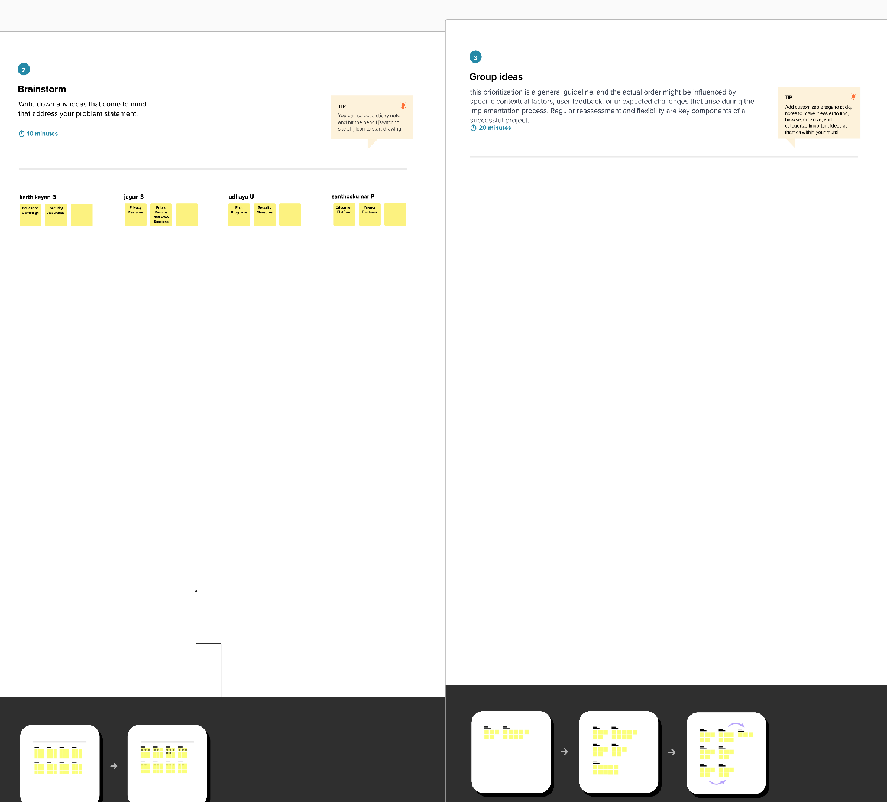

4.REQUIREMENT ANALYSIS:

4.1Functional requirement:
Smart Contract Architecture:
Define the architecture of the smart contract, including the choice of blockchain platform (e.g., Ethereum, Binance Smart Chain) and the programming language (e.g., Solidity).
Token Creation and Management:
Implement the creation and management of digital tokens representing the central bank's currency.
Specify the process for issuing new tokens and handling token burns.
Transaction Processing:
Define the rules and processes for validating and processing transactions on the blockchain.
Ensure the security and integrity of transactions.
Identity Verification:
Implement a secure and reliable identity verification system for users engaging in transactions.
Ensure compliance with regulatory requirements related to identity verification.
Monetary Policy Implementation:
Specify how the smart contract will enforce and execute monetary policies set by the central bank.
Define parameters for interest rates, inflation targeting, and other monetary tools.

  - Non-Functional requirements:
Security:
Data Encryption: Ensure that sensitive data related to monetary transactions, user identities, and financial records are encrypted to prevent unauthorized access.
Authorization and Authentication: Implement a robust system for user authentication and authorization, restricting access to critical functions and data based on roles and permissions.
Smart Contract Security: Perform thorough code audits and testing to identify and mitigate vulnerabilities in smart contracts to prevent exploits or attacks.
Scalability: Design the smart contracts and underlying infrastructure to handle a high volume of transactions, considering potential future growth in the number of users and transactions.
Latency: Define acceptable response times for transactions and ensure that the system meets these criteria to provide a seamless user experience.
Fault Tolerance: Implement mechanisms to detect and recover from failures promptly, ensuring minimal disruption to the operation of the central bank's financial infrastructure.

Redundancy: Introduce redundancy in critical components to ensure system availability in the event of hardware failures or other unforeseen issues.
Regulatory Compliance: Ensure that the smart contracts adhere to all relevant financial regulations and compliance standards set by the central bank and other regulatory bodies.
Auditability: Enable comprehensive logging and auditing functionalities to facilitate regulatory compliance audits and investigations.
Integration with Existing Systems: Design the smart contract system to seamlessly integrate with the central bank's existing financial systems, promoting interoperability and data consistency.
Standardization: Follow industry standards and protocols to enhance compatibility with external financial institutions and systems.
User Interface: Develop a user-friendly interface for interacting with the smart contract system, considering the diverse set of users, including central bank officials, financial institutions, and other stakeholders.
Documentation: Provide comprehensive documentation for developers, auditors, and end-users to understand the functionality, usage, and limitations of the smart contract system.
Upgradability: Plan for future upgrades and improvements to the smart contract system, ensuring that new features can be seamlessly integrated without disrupting existing operations.
Code Maintainability: Adhere to best coding practices and documentation standards to facilitate easy maintenance and updates by development teams.

5. PROJECT DESIGN:
  - Data Flow Diagram:
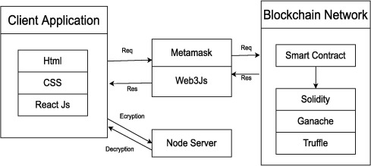
5.2SOLUTION ARCHITECTURE:

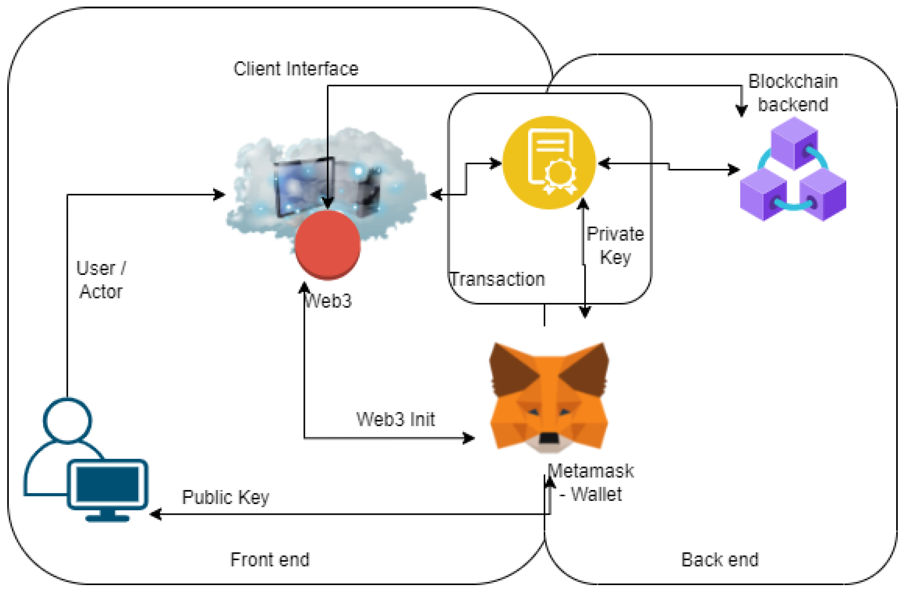

PROJECT PLANNING:
  - Technical Architecture:
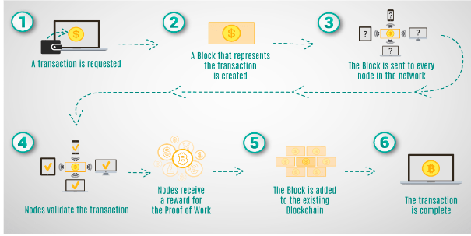

7.CODING & SOLUTIONING:
SPDX-License-Identifier: MIT:
This is a SPDX license identifier indicating that the smart contract is licensed under the MIT License.
Solidity Version:
The pragma statement specifies that the code should be compiled using Solidity version 0.8.0 or a compatible version.
Contract Structure:
The Bank contract includes state variables, functions, and a constructor.
State Variables:
address public owner: Declares a state variable to store the address of the owner of the contract.
Mapping (address => uint256) public balances: Defines a mapping to associate Ethereum addresses with corresponding balance amounts.
Constructor:
Constructor(): Initializes the owner variable with the address of the deployer of the contract.
Modifier:
modifier only Owner(): Defines a modifier named onlyOwner, which restricts access to certain functions to only the owner of the contract.
Functions:
Mint Money (uint256 amount) external onlyOwner: Allows the owner to mint (create) new money by increasing their balance.
Withdraw Money (uint256 amount) external: Enables users to withdraw money from their balance, provided they have sufficient funds.
Transfer Funds (address payable receipent Address, Uint _amount) public onlyOwner: Allows the owner to transfer funds from their balance to another address.
Check Balance() external view returns (uint256): Allows users to check their account balance.
Functionality Details:
The mint Money and withdraw Money functions have checks to ensure that the provided amount is greater than 0 and that the user has a sufficient balance, respectively.
The transfer Funds function transfers funds from the owner's balance to a specified recipient address, with a check for sufficient balance.
Ownership Control:
The onlyOwner modifier and associated checks in functions ensure that certain operations, such as minting money and transferring funds, can only be performed by the owner of the contract.
.

7.1Feature:
Decentralized Ledger:
Utilize blockchain technology to maintain a decentralized and tamper-resistant ledger of all financial transactions conducted by the central bank.
Smart Contract Automation:
Implement smart contracts for automated execution of financial processes, reducing the need for manual intervention and streamlining operations.

8.PERFORMANCE TESTING

S.No. | Parameter | Values | Screenshot
1. | Information gathering | Setup all the Prerequisite: | 
2. | Extract the zip files | Open to vs code | 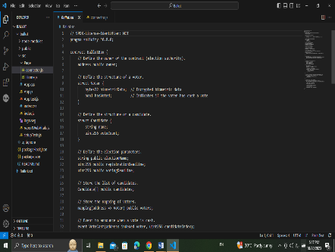
3. | Remix Ide platform explorting | Deploy the smart contract code  Deploy and run the transaction. By selecting the environment - inject the MetaMask. | 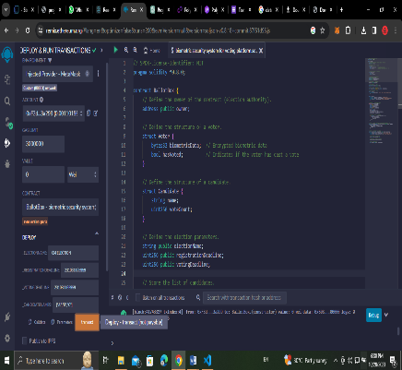
4 | Open file explorer | Open the extracted file and click on the folder.  Open src, and search for utiles.  Open cmd enter commands  1.npm install  - Npm install bootstrap  - npm start | 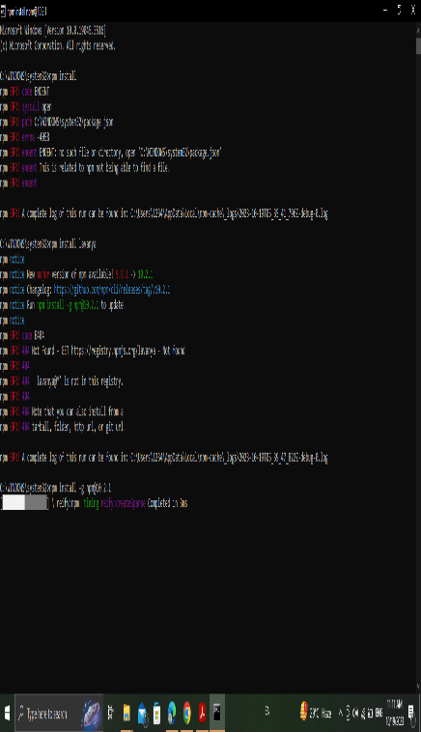
5 | {LOCALHOST IP ADDRESS | copy the address and open it to chrome so you can see the front end of your project. | 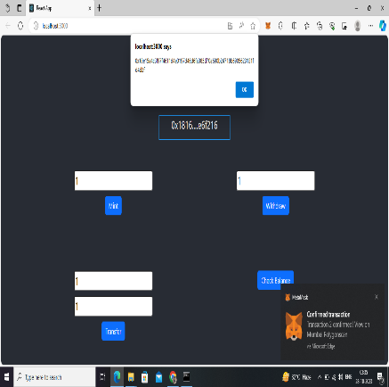

9.RESULTS:
9.1Output Screenshots: 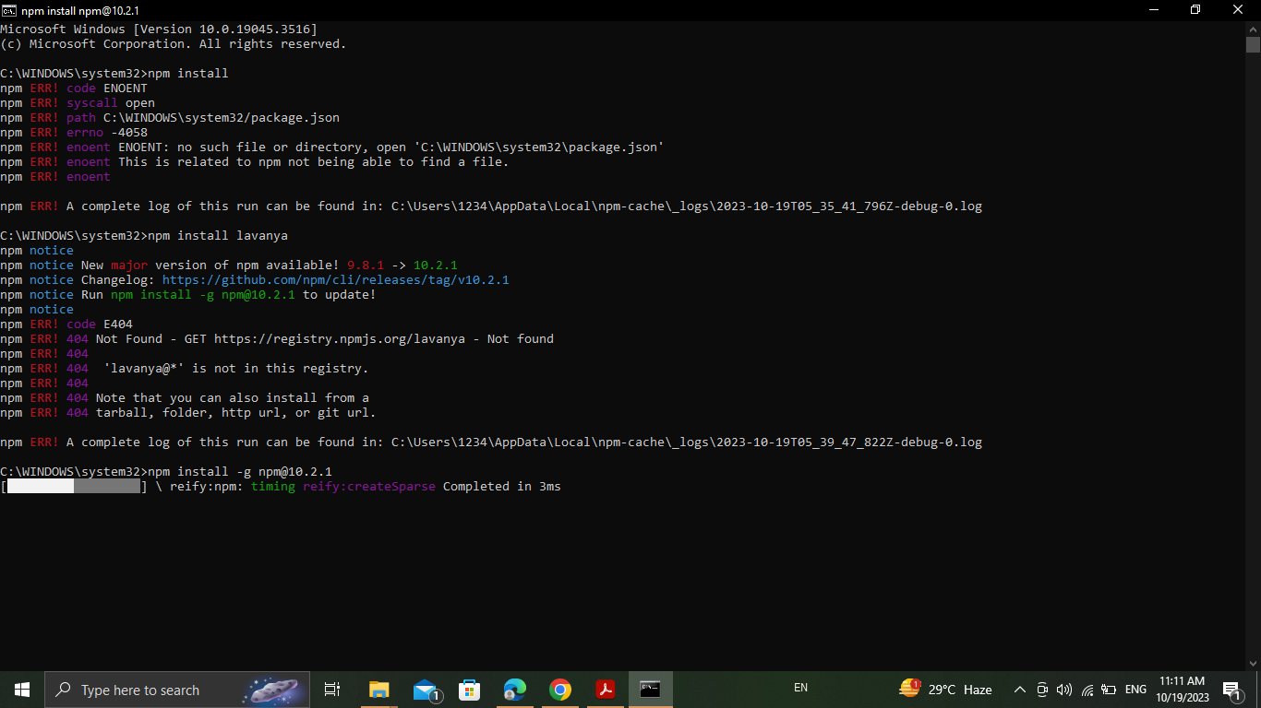
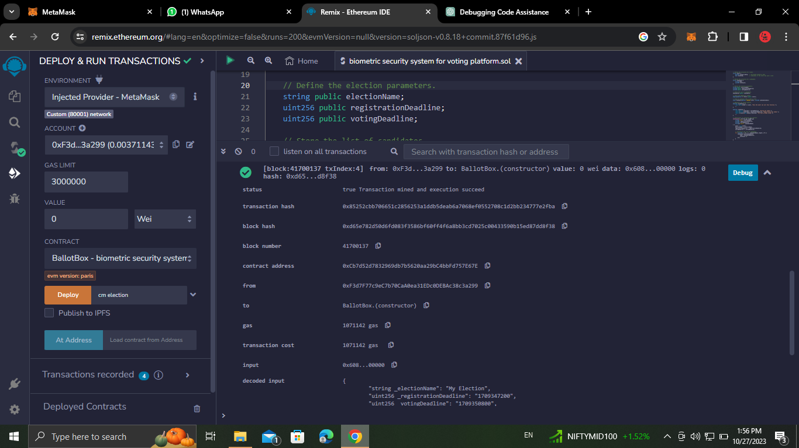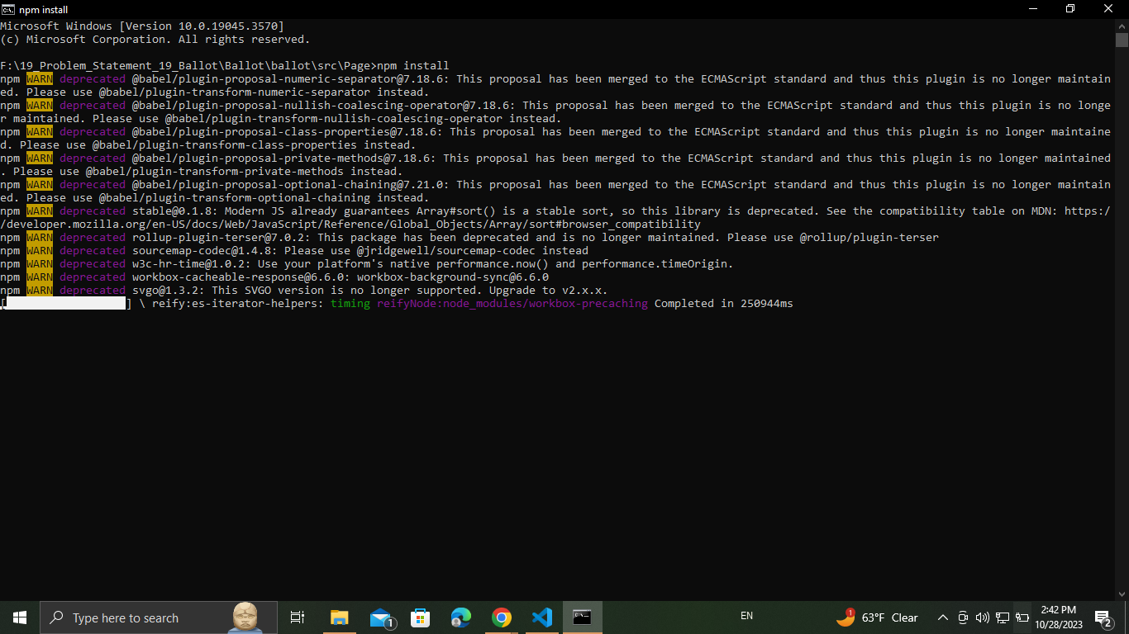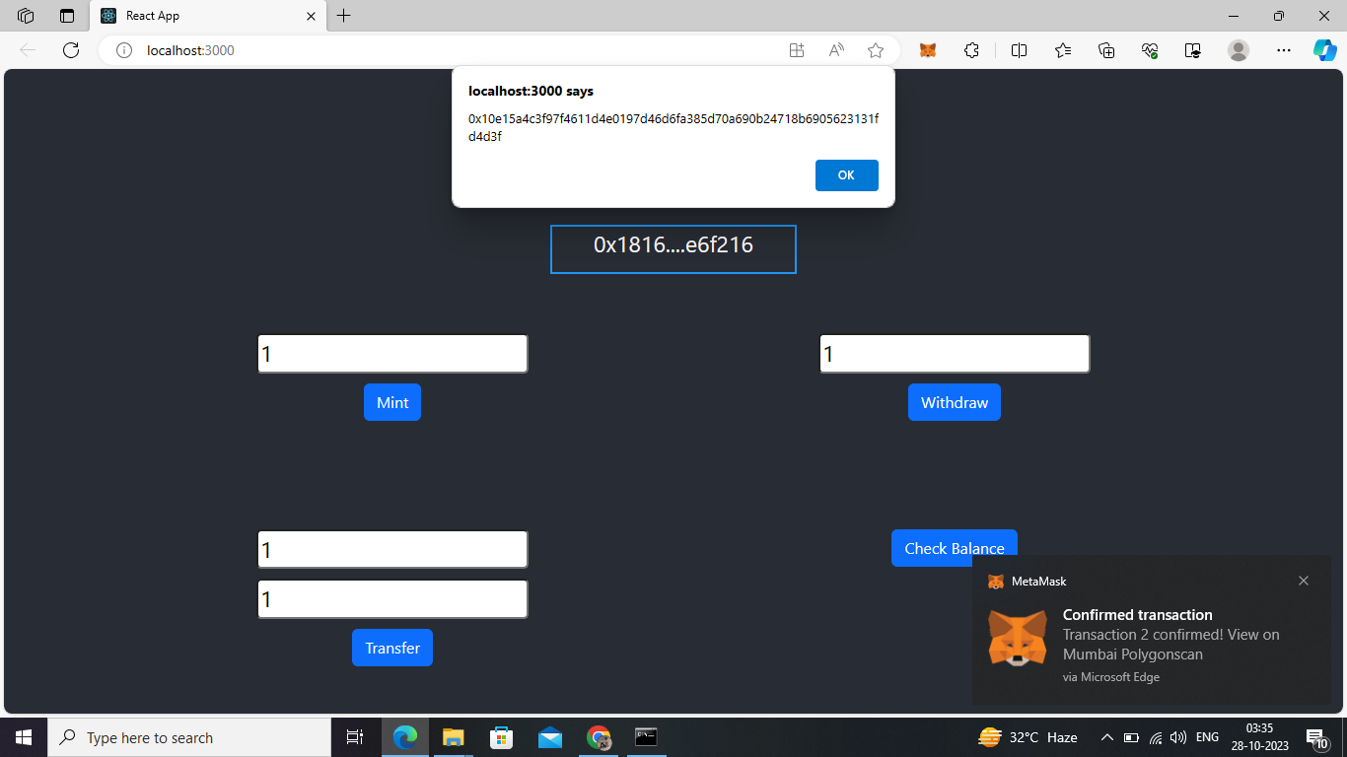

10. ADVANTAGES & DISADVANTAGES:

10.1 Advantages:
Efficiency and Automation:
Smart contracts automate various financial processes, reducing the need for manual intervention and increasing operational efficiency.
Transparency:
The use of blockchain ensures transparency in transactions, providing a clear and immutable record of all financial activities.
Reduced Fraud:
The tamper-resistant nature of blockchain technology reduces the risk of fraud and unauthorized activities within the financial system.
Faster Transactions:
Smart contracts enable near-instantaneous settlement of transactions, reducing the time and cost associated with traditional banking processes.
Financial Inclusion:
Digital currencies and smart contracts can improve financial inclusion by providing access to banking services for underserved populations.

10.2Disadvantages:
Technical Complexity:
Implementing and maintaining a central bank smart contract system requires a deep understanding of blockchain technology, which may be a barrier for some institutions.
Security Concerns:
Smart contracts are not immune to security vulnerabilities, and any flaws in the code could lead to financial losses or unauthorized access.
Regulatory Uncertainty:
The regulatory landscape for blockchain and digital currencies is still evolving, and uncertainties may pose challenges for central banks in terms of compliance.
Scalability Issues:
As transaction volumes increase, scalability can become a concern, requiring careful design to handle a growing number of transactions.
11.CONCLUSION:
Central bank smart contracts offer a promising avenue for enhancing the efficiency, transparency, and security of monetary transactions. By leveraging blockchain technology, these contracts can automate various financial processes, reducing the risk of errors and fraud. Additionally, the decentralized nature of smart contracts ensures a transparent and tamper-resistant system.

However, challenges such as scalability, regulatory concerns, and the need for a robust security framework must be addressed to fully realize the potential benefits. Striking the right balance between innovation and risk management is crucial for the successful implementation of central bank smart contracts.

FUTURE SCOPE:
Decentralized Monetary Policy Execution: Smart contracts could automate the execution of monetary policies, adjusting interest rates or money supply based on predefined conditions. This could lead to more efficient and transparent monetary policy implementation.

Real-Time Economic Data Analysis: Smart contracts could be programmed to analyze real-time economic data. This would enable central banks to make quicker and more informed decisions based on the most current information available.

Cross-Border Transaction: Central bank digital currencies (CBDCs) integrated with smart contracts could streamline cross-border transactions. Smart contracts could automatically enforce compliance with international regulations, reducing the need for intermediaries and increasing the speed of transactions.

1. APPENDIX
13.1Source Code:
// SPDX-License-Identifier: MIT
pragma solidity ^0.8.0;

contract Bank {
address public owner;
mapping(address => uint256) public balances;

constructor() {
owner = msg.sender;
}

modifier onlyOwner() {
require(msg.sender == owner, "Only contract owner can call this");
_;
}

function mint Money (uint256 amount) external onlyOwner {
require(amount > 0, "Amount must be greater than 0");
balances[msg.sender] += amount;
}

function withdraw Money (uint256 amount) external {
require(balances[msg.sender] >= amount, "Insufficient balance");
balances[msg.sender] -= amount;
}

function transfer Funds (address payable receipent Address,uint _amount) public only Owner

{
require(balances[msg.sender] >= _amount, "Insufficient balance");
balances [msg.s ender] -= _amount;
balances [receipent Address] += _amount;
}

function check Balance() external view returns (uint256) {
return balances[msg.sender];
}
}

}
13.2 GitHub & Project Demo Link:

